1. Create a project by clicking on the Scrum as shown below.

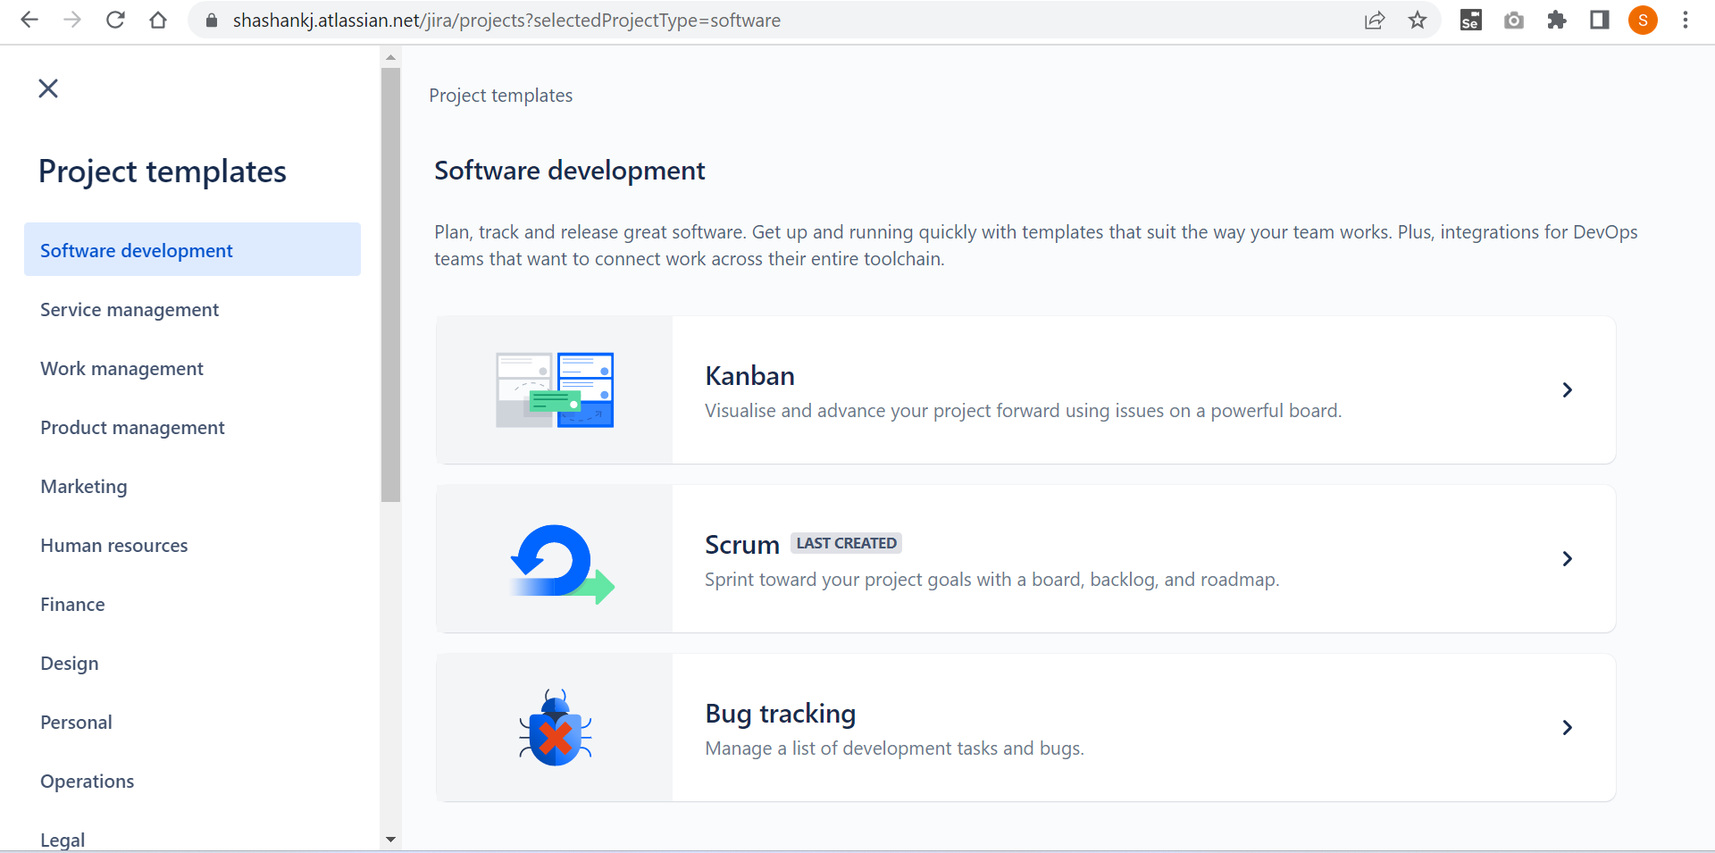

2.Click on the ‘Select a company-managed project.

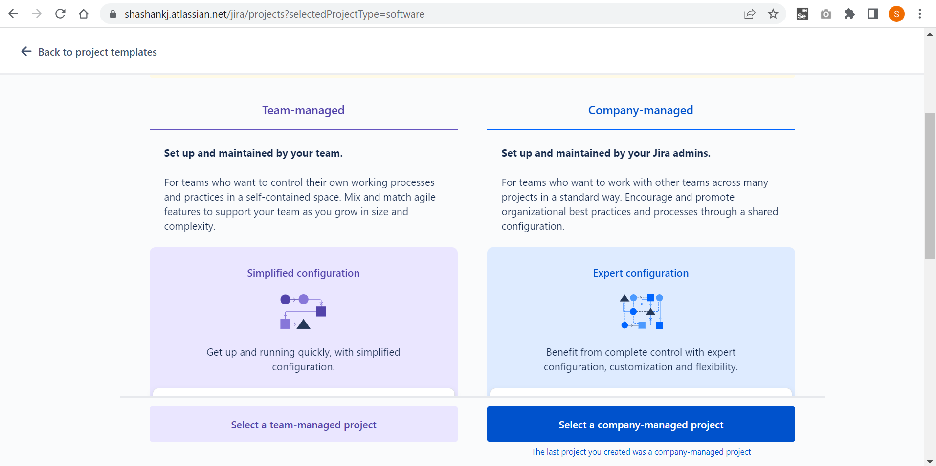

3.Once you create a project, create a version by navigating to the backlog and also create an epic

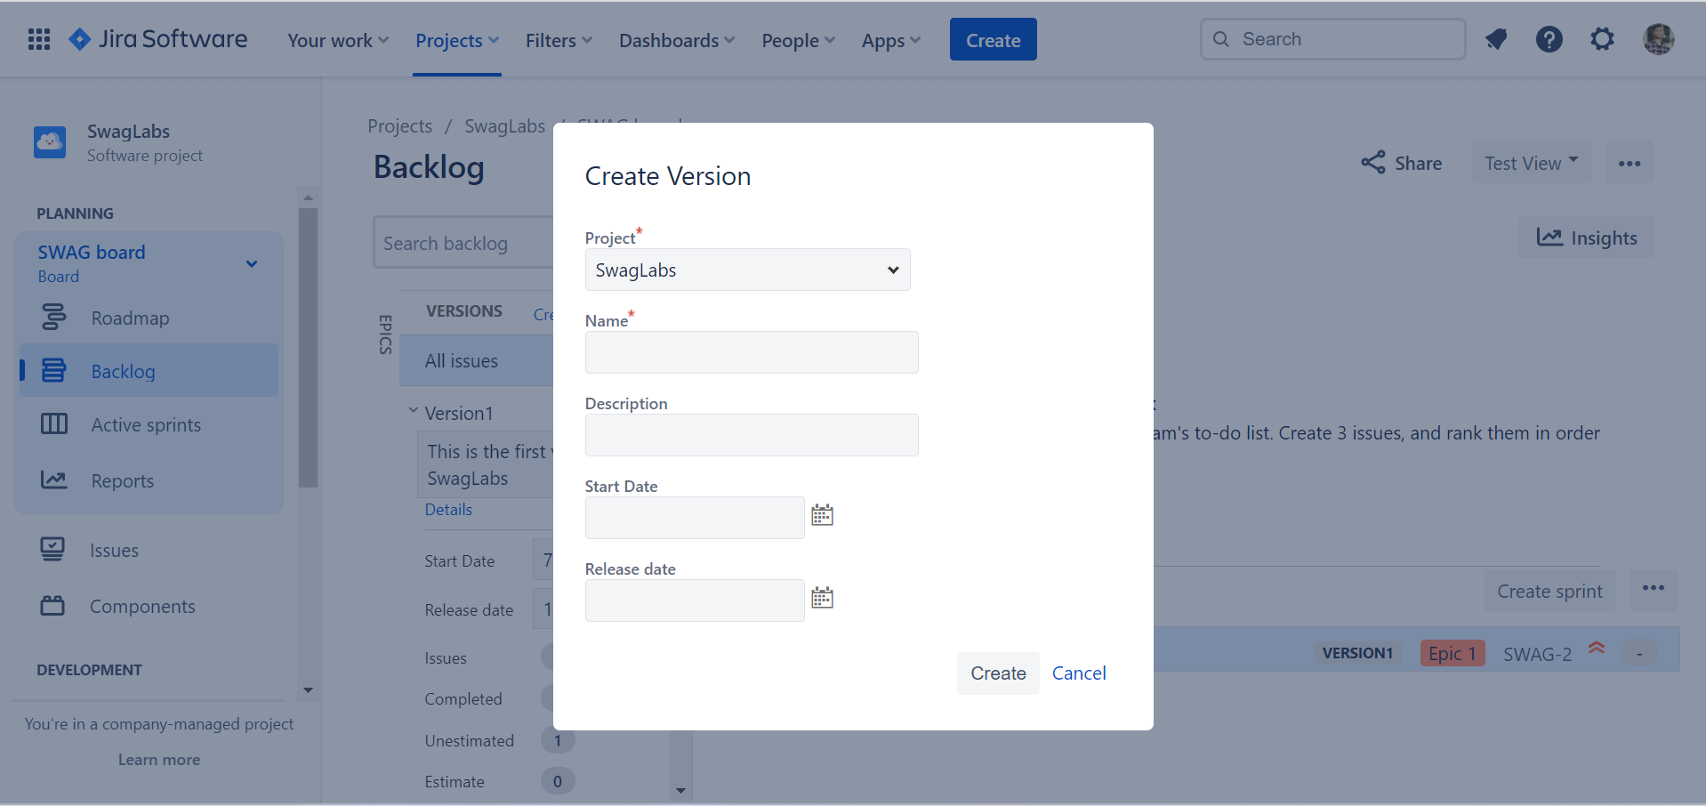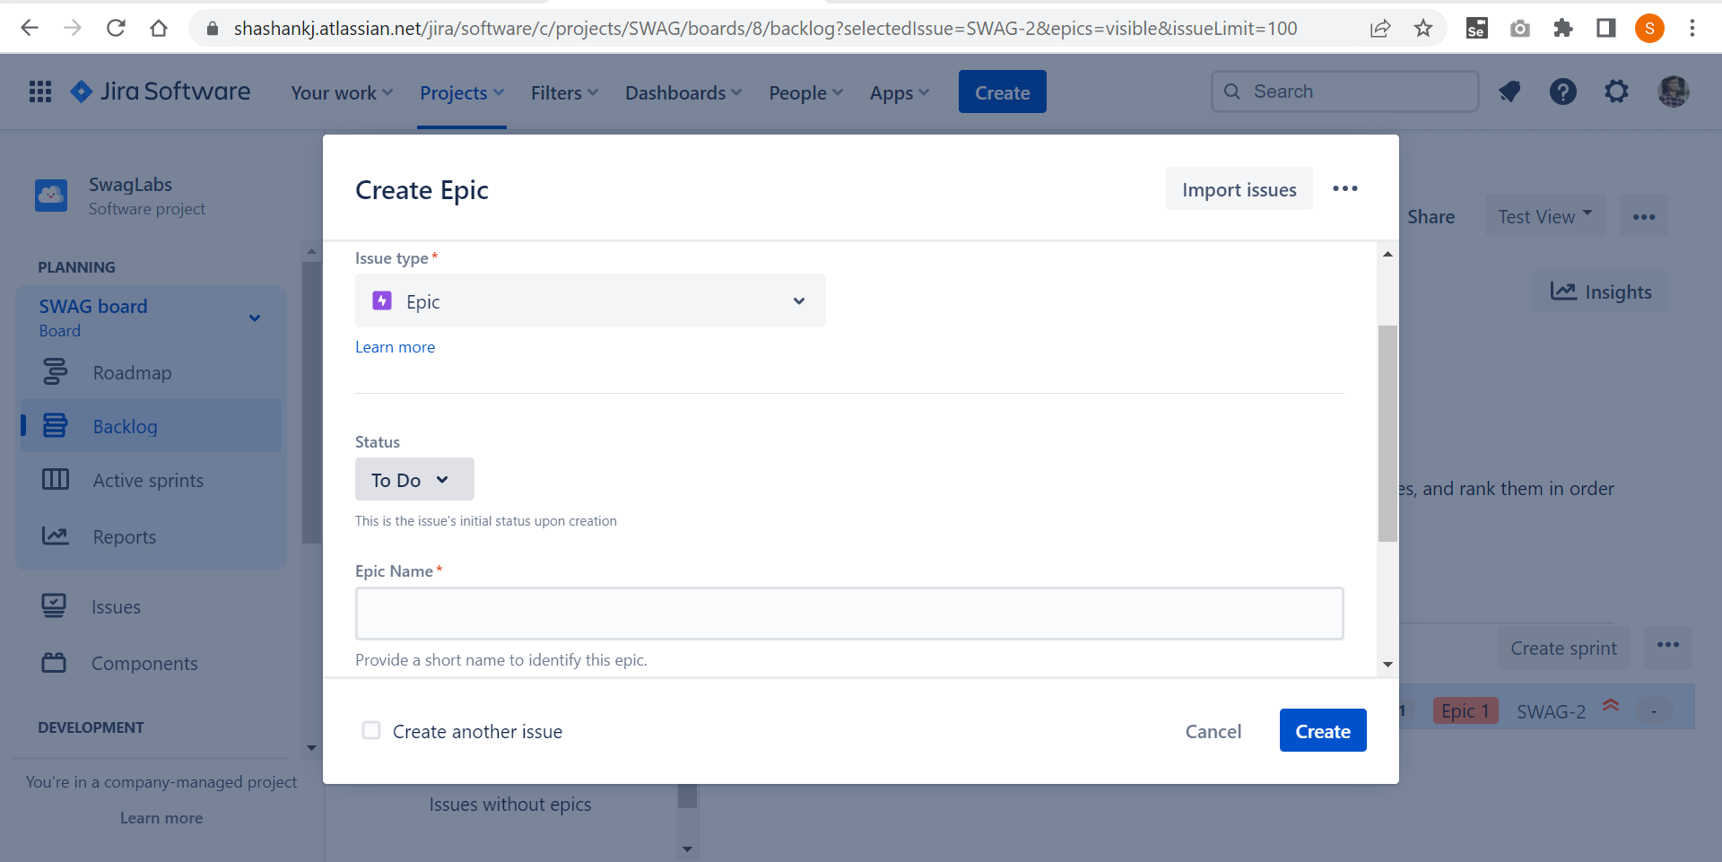

4.Create a user story by clicking on the create button in the home page 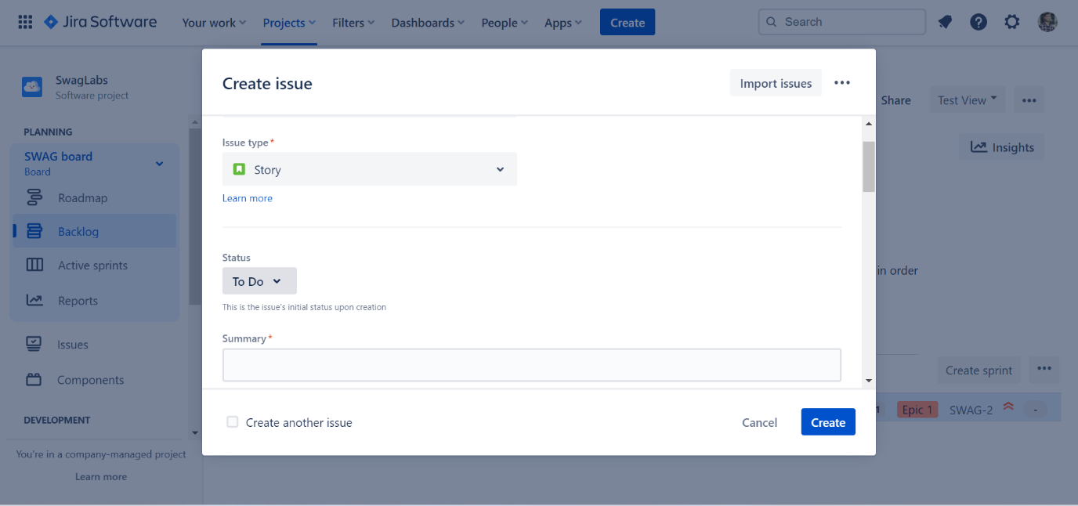

5.After creating the user stories, create the sprint in the backlog and then add all the user stories to the sprint.

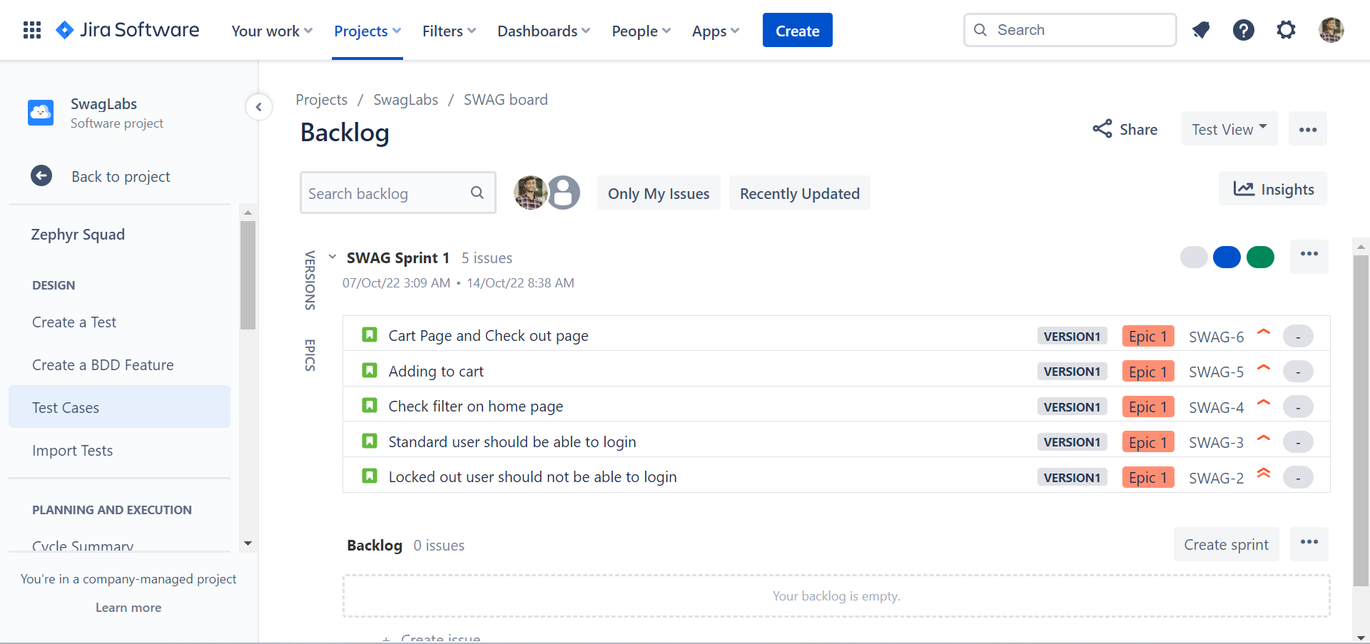

6.Also assign the story points to the user stories.

7. Import the test cases by navigating to the Zephyr squad -> Import test case.

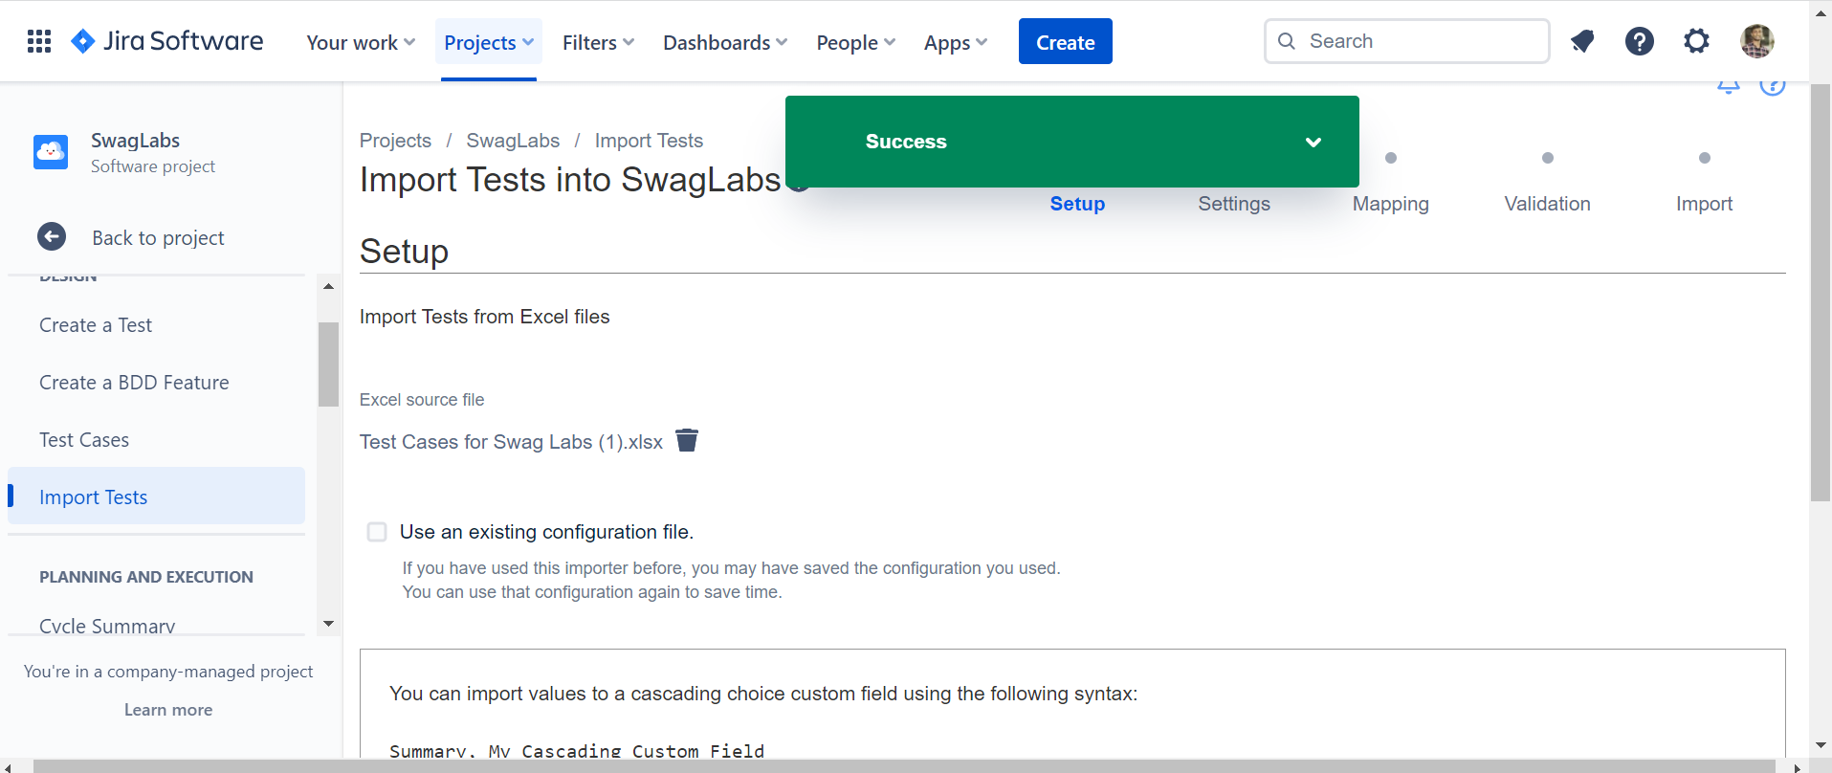

8. In the zephyr squad ,we can see the test cases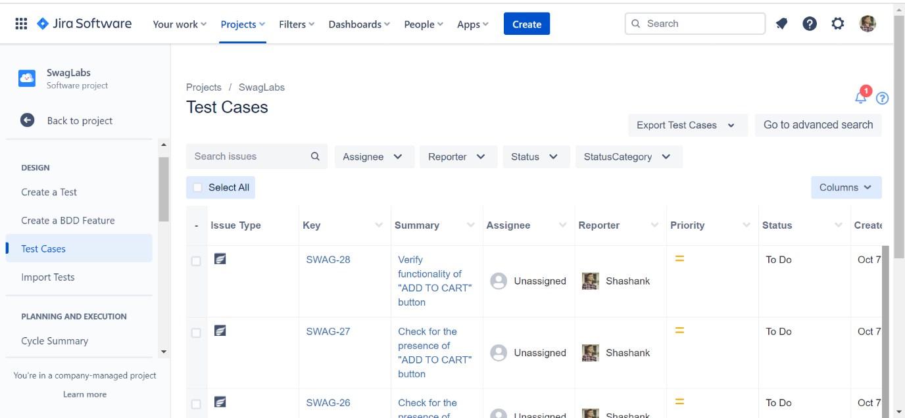

9. By clicking the on the key, we can execute the test cases .

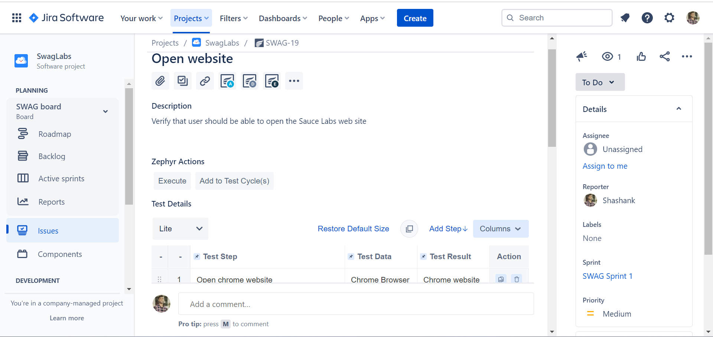

10.Create the test cycle by clicking on the cycle summary in the zephyr squad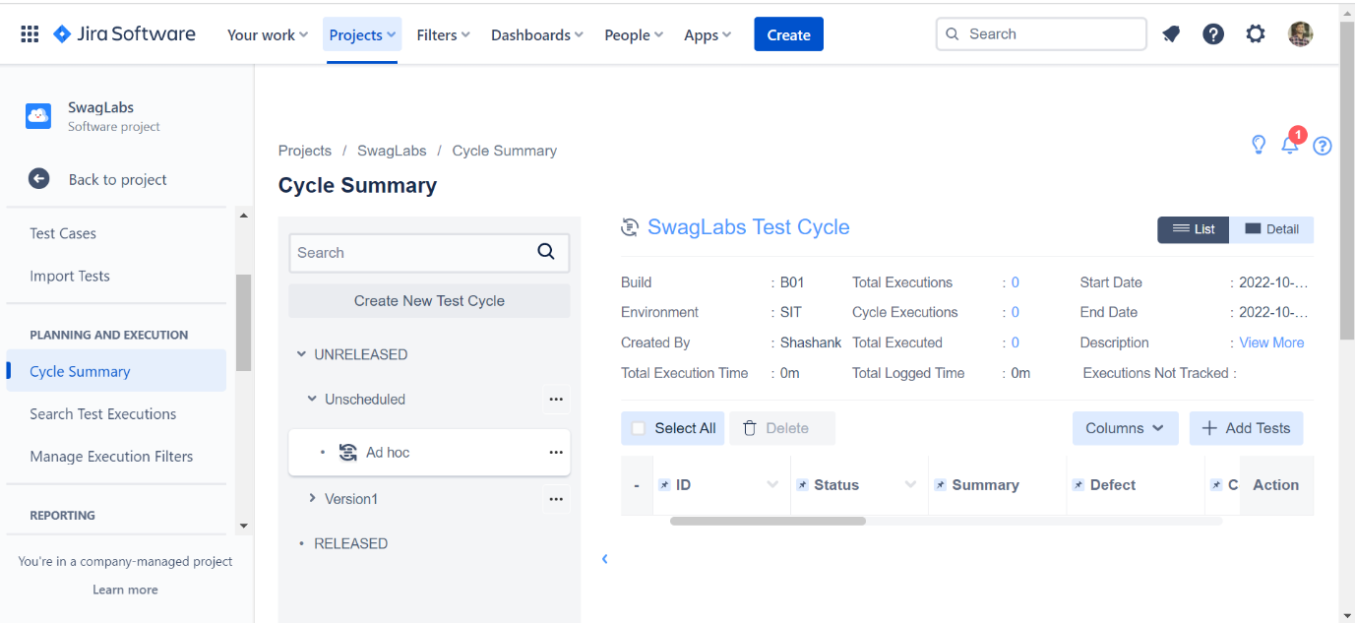.

11.Check each steps in the test cases, and assign the status of the test step.

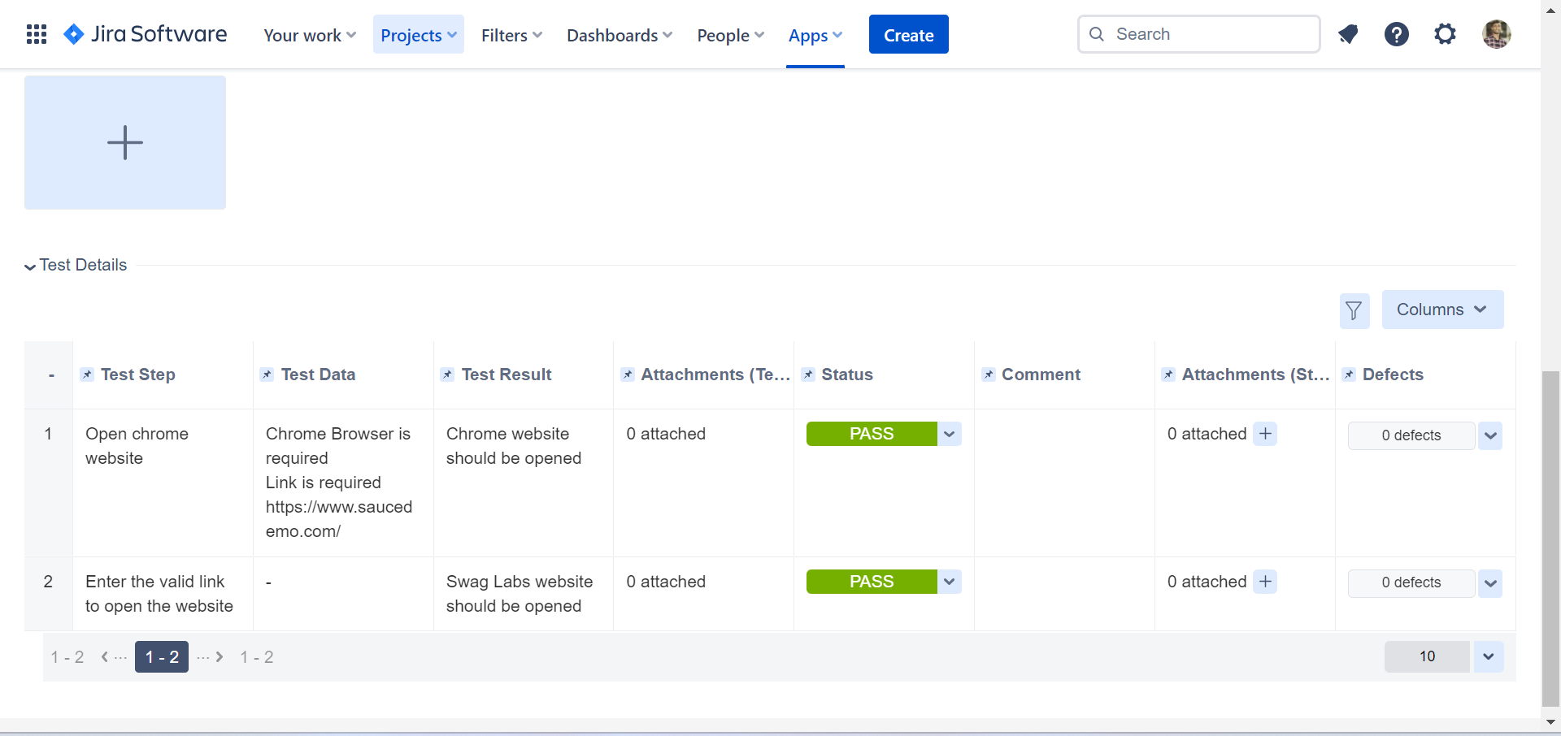

12. Add the execution status and then add the attachment.

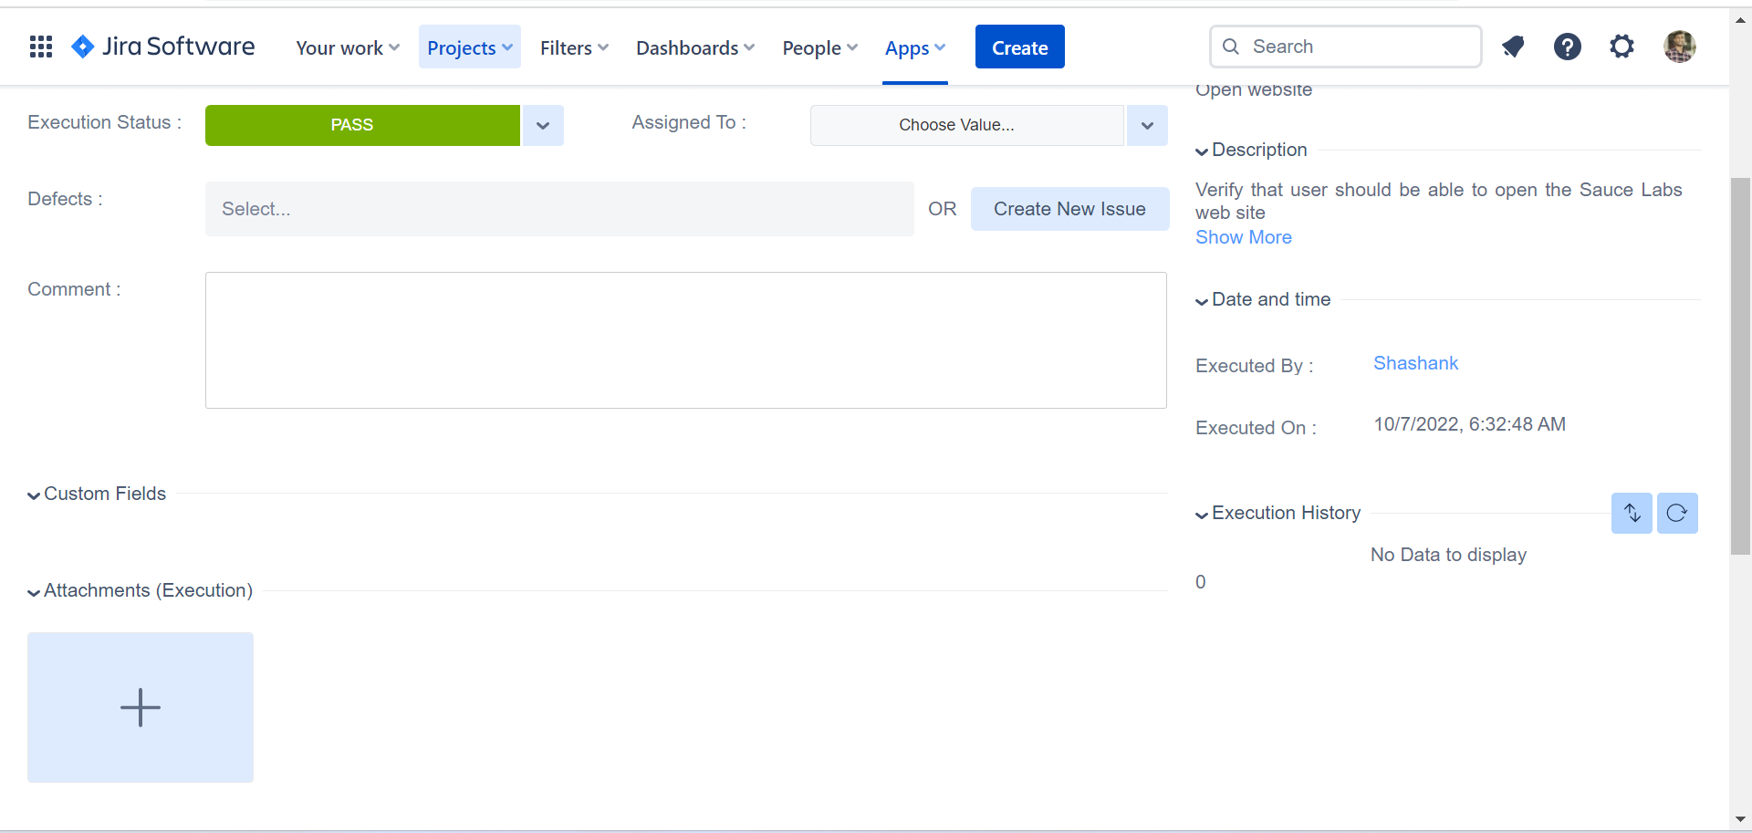

13. similarly ,if test fails mark it as fail and assign it to developer and add comment also add attachment

